|  |
| --- |
| WORK EXPERIENCE  Have worked in a studio for two years as photographer and graphic designer.  Have worked in a call center agent in ipsos company.  Have also done volunteering in several events including IRON MAN event.  Currently working part time as a data collector in a marketing company. |
| EDUCATION  **Acedemic qualification** S.S.C(secondary school certificate):- Pakistan school bahrain(2011-2012)  H.S.S.C(higher school certificate)(commerce group):- Pakistan school Bahrain (2013-2014)  **Additional qualification**  Knowledge of micro soft excel, word, powerpoint, adobe photoshop. Have achieved several certificates in IT competitions. |

MUHAMMAD HASEEB MUHAMMAD YASIN.

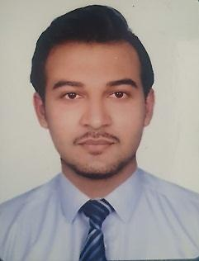



[**BESTOFHASEEB@YAHOO.COM**](mailto:BESTOFHASEEB@YAHOO.COM)



+97334228001

# CPR

950814610

**ADDRESS** FLAT;-3 BUILDING:-1722 ROAD:-2559 BLOCL: 0925

OBJECTIVE

To have a ‘vision’ to be successful and give my best in any situation.

To work in a challenging environment in a position to refine my experience and skills, while serving my best to the organization with the opportunity to learn, earn and grow on personal abilities.

AREA:-RIFFA/BU KWARAH

# RELIGION

ISLAM

# LANGUAGES(WRITTEN&SPOKEN)

ENGLISH URDU ARABI



|  |  |
| --- | --- |
| **DATE OF BIRTH**  18/08/1995  **NATIONALITY**  PAKISTANI  **GENDER**  MALE  **VISA STAUS**  STUDENT  **MARTIAL STATUS**  SINGLE  **HOBBIES**  GRAPHIC DESIGNING PHOTOGRAPHY PLAYING GAMES  WORKOUT  DRIVING  **SKILLS**  TIME MANAGEMENT TROUBLE SHOOTING  MULTI TASKING  EFFECTIVE COMMUNICATION. | **DECLARATION**  I hereby declare that the above mentioned information is correct and true to the best of my knowledge and belief. I assure your good office that I will work to the best of my abilities and diligently perform all that assigned to to your fullest satisfaction  **Reference**:- will be provided if required. |

h

